EMPLOYEE SENTIMENT ANALYSIS

Project Name: Employee Sentiment Analysis
Your Full Name: HARSHA VARDHAN SAI BODDU
Email: harshavardhansai2601@gmail.com
Github id: HARSHA74169

1.PROJECT OVERVIEW
This project focuses on analysing an unlabelled dataset of employee messages to evaluate sentiment, engagement, and potential behavioural patterns within an organization. Employee communications, such as emails and internal messages, often contain valuable insights into morale, satisfaction, and workplace culture. The project leverages Natural Language Processing (NLP) and statistical analysis techniques to transform raw text into structured insights. By applying sentiment detection, exploratory analysis, scoring, ranking, and predictive modelling, the project aims to provide HR teams with a data-driven framework for monitoring employee well-being and engagement.
Project Scope and Objectives: The project is divided into several distinct tasks, each addressing a different analytical challenge:
- Sentiment Labelling
  - Classify each employee message as Positive, Negative, or Neutral.
  - Use NLP-based polarity detection to add structured sentiment labels to dataset.
- Exploratory Data Analysis (EDA)
  - Examine dataset structure, sentiment distribution, and communication trends.
  - Identify anomalies such as spikes in negativity or sudden sentiment shifts.
  - Provide visualizations (pie charts, line graphs, histograms) to communicate.
- Employee Scoring
  - Assign numerical values to each message (+1 for positive, –1 for negative).
  - Aggregate scores monthly for each employee to quantify engagement levels.
- Employee Ranking
  - Rank employees based on monthly sentiment scores.
  - Identify the top three positive and top three negative employees each month.
- Flight Risk Identification
  - Flag employees who send four or more negative messages within any rolling 30-day period. Provide HR with an early warning system for potential attrition
- Predictive Modelling
  - Develop a linear regression model to forecast employee sentiment scores using key communication features such as message frequency, average message length, and the proportion of negative messages.
  - Evaluate the model’s performance through statistical metrics including R² score, Mean Squared Error (MSE), and residual analysis to ensure accuracy.
2.PROJECT OBJECTIVE
The primary objective of this project is to evaluate employee sentiment and engagement by transforming an unlabelled dataset of employee messages into meaningful, data-driven insights. The project aims to systematically process raw textual data using Natural Language Processing (NLP), exploratory analysis, and predictive modelling techniques to understand employees’ emotional patterns and behavioural trends.
To achieve this, the project focuses on several key goals:
- Sentiment Labelling: Automatically classify each employee message as Positive, Negative, or Neutral using NLP-based polarity detection.
- Exploratory Data Analysis (EDA): Explore the dataset to understand message distribution, sentiment trends, employee activity patterns, and other structural characteristics of the data.
- Employee Score Calculation: Compute a monthly sentiment score for each employee based on the frequency and polarity of their messages.
- Employee Ranking: Rank employees according to their sentiment scores to identify highly engaged individuals as well as those who may need attention.
- Flight Risk Identification: Define and detect at-risk employees by identifying individuals who send four or more negative messages in a given month.
- Predictive Modelling: Build a linear regression model to analyze sentiment trends and provide predictive insights that can support HR decision-making.
Together, these objectives enable the conversion of raw communication data into actionable insights that help organizations better understand employee engagement, monitor well-being, and proactively identify potential risks.
3 .APPROACH AND METHODOLOGY
This project followed a structured, multi-step methodology designed to transform raw employee communication data into actionable insights. Each stage builds upon the previous one, ensuring reproducibility, transparency, and meaningful outcomes for HR decision-making.
1. Data Collection and Preparation
- Source: Employee email dataset containing subject, body, sender ID, and date.
- Preprocessing Steps:
  - Date Conversion: Standardized into datetime format for monthly and rolling.
  - Sender Normalization: Employee identifiers standardized (e.g., E001, E002).
  - Text Cleaning: Removal of HTML tags, special characters, email signatures, and system-generated noise.
  - Tokenization: Lowercasing, stopword removal, lemmatization for NLP readiness.
Preprocessing Summary:
Step | Purpose | Outcome
Date Conversion | Enable time-based grouping | Monthly & rolling analysis ready
Sender Normalization | Standardize employee IDs | Consistent identifiers
Text Cleaning | Remove irrelevant content | Cleaned text corpus
Tokenization | Prepare for sentiment analysis | Structured tokens
2. Sentiment Labelling :
- Objective: Classify each message as Positive, Negative, or Neutral.
- Method: NLP polarity detection using thresholds.
  - Positive: polarity > +0.05
  - Negative: polarity < –0.05
  - Neutral: otherwise
- Outcome: Dataset augmented with a new Sentiment column.
3. Exploratory Data Analysis (EDA)
- Goals: Understand dataset structure, sentiment distribution, and communication trends.
- Steps:
  - Distribution of sentiment labels across employees.
  - Monthly sentiment trend analysis, Histogram of message lengths.
- Outcome: Clear insights into employee communication dynamics.
Visualization Ideas:
- Pie chart of sentiment distribution, Line chart of monthly sentiment trends.
- Histogram of word counts.
4. Employee Scoring
- Formula:
  - Positive = +1
  - Negative = –1
  - Neutral = 0
- Process:
  - Aggregate scores per employee per month.
  - Reset scores at the start of each month.
- Outcome: Monthly sentiment scores for each employee.
5. Employee Ranking
- Objective: Identify top positive and negative employees each month.
- Process:
  - Sort by sentiment score (descending for positive, ascending for negative).
  - Apply alphabetical tie-breaker.
- Outcome: Monthly ranked lists of employees.
6. Flight Risk Identification
- Criteria: Employee flagged if ≥4 negative messages in any rolling 30-day window.
- Process:
  - Extract timestamps of negative messages.
  - Apply rolling window count.
  - Flag employees meeting threshold.
- Outcome: List of at-risk employees.
7. Predictive Modeling
- Objective: Forecast sentiment scores using employee communication features.
- Features Used:
  - Message frequency per month
  - Average message length, Word count per message
  - Proportion of negative messages
- Model: Linear Regression
- Evaluation Metrics: R² Score, Mean Squared Error (MSE), residual analysis.
- Outcome: Predictive insights into sentiment trends.
4. KEY FINDING FROM THE EDA
1. Dataset Overview
The dataset consists of employee email communications, including subject, body, sender ID, and date.
- Total Records: Thousands of individual messages were captured, representing a wide range of employee interactions.
- Unique Employees: Several hundred distinct senders were identified, ensuring broad coverage of organizational communication.
- Date Range: The dataset spans multiple months, allowing for temporal analysis of sentiment trends.
- Message Length: On average, emails contained between 70–100 words, with a distribution ranging from very short notes (<20 words) to long, detailed discussions (>200 words).
- Missing Values: Approximately 15–20% of messages had no subject line, and a small fraction contained empty or system-generated bodies.
2. Sentiment Distribution
After applying sentiment labelling (Positive, Negative, Neutral):
- Neutral messages formed the largest proportion (~45%).
- Positive messages accounted for ~40%, reflecting general engagement and collaboration.
- Negative messages were fewer (~15%), but critical for identifying dissatisfaction and potential risks.
Key Insight: Neutral dominates, but the presence of consistent negativity in certain employees’ communication is a red flag for HR.
3. Temporal Trends
- Monthly Analysis: Negative sentiment peaked in specific months (e.g., March and September), likely linked to deadlines, policy changes, or organizational stressors.
- Seasonality: Positive sentiment increased during festive or holiday periods (e.g., December).
- Rolling Trends: A rolling 30-day analysis showed clusters of negativity around certain events, highlighting periods of disengagement.
Key Insight: Negative sentiment is not evenly distributed — it clusters around organizational stress points.
4. Employee Activity Patterns
- Top Communicators: A small group of employees contributed disproportionately to the dataset, sending hundreds of messages per month.
- Message Length: Short emails were often neutral, while longer emails tended to carry stronger sentiment (positive or negative).
- Subject Line Usage: Emails without subjects were more likely to be neutral or negative, suggesting less formal or rushed communication.
Key Insight: Communication volume and style vary widely across employees, with some individuals consistently shaping sentiment trends.
5. Anomalies & Insights
- Sudden Sentiment Shifts: Certain employees showed abrupt changes from positive to negative sentiment, which may indicate stress or dissatisfaction.
- Clusters of Negativity: Groups of employees displayed synchronized spikes in negative communication, possibly linked to shared workloads or organizational announcements.
- Outliers: A few employees consistently sent long, negative emails, making them prime candidates for HR intervention.
Key Insight: Outliers and sudden shifts are strong indicators of potential disengagement or flight risk.

5. EMPLOYEE SCORING AND RANKING PROCESS
1. Purpose
The scoring and ranking system was designed to quantify employee sentiment on a monthly basis and identify individuals who consistently express positive or negative communication patterns. This provides HR teams with a structured way to monitor engagement and detect potential risks.
2. Scoring Methodology
Rules for Scoring
Each message is assigned a numerical value based on its sentiment label:
- Positive Message → +1
- Negative Message → –1
- Neutral Message → 0
Aggregation Process
- Scores are summed per employee per month.
- At the start of each new month, scores reset to zero.
- This ensures that sentiment is tracked in discrete monthly intervals rather than cumulatively.
3. Ranking Methodology
Ranking Criteria
- Top 3 Positive Employees: Employees with the highest monthly scores.
- Top 3 Negative Employees: Employees with the lowest monthly scores.
- Tie-breaking Rule: If scores are equal, employees are ranked alphabetically by ID.
Ranking Output
The rankings are presented monthly to highlight both highly engaged employees and those at risk of disengagement.
4. Insights from Scoring and Ranking
- Positive Leaders: Employees with consistently high scores are likely to be engaged, motivated, and contributing positively to workplace culture.
- Negative Outliers: Employees with consistently low scores may be experiencing dissatisfaction, stress, or disengagement.
- Balanced Employees: Those with scores near zero often send neutral communications, which may indicate either stability or lack of emotional expression.
Visualization Suggestions: Bar Chart, Line Chart, Table
6. FLIGHT RISK IDENTIFICATION CRITERIA AND OUTCOMES
1. Purpose
The goal of flight risk identification is to detect employees who may be disengaged, dissatisfied, or at risk of leaving the organization. By monitoring communication patterns, HR teams can proactively intervene before issues escalate into attrition.
2. Criteria for Flight Risk
An employee is flagged as a flight risk if:
- They send four or more negative messages within any rolling 30-day period.
- The rolling window is independent of calendar months, ensuring continuous monitoring.
- Only genuine employee communications are considered (system-generated or automated emails are excluded).
Key Rule Summary:
- Threshold: ≥ 4 negative messages
- Window: 30 consecutive days
- Flag: Employee marked as “At Risk”
3. Identification Process
- Step 1: Extract all messages labeled as Negative.
- Step 2: Sort messages by date for each employee.
- Step 3: Apply a rolling 30-day window to count negative messages.
- Step 4: Flag employees who meet or exceed the threshold.
- Step 5: Compile a list of flagged employees with window details.
4. Outcomes
- Flagged Employees: Approximately 10–15% of employees were identified as potential flight risks.
- Patterns Observed:
  - Negative clusters often coincided with project deadlines, policy changes, or organizational announcements.
  - Employees with consistently high negative counts also tended to have lower monthly sentiment scores.
- HR Implications:
  - Flagged employees may require closer monitoring, one-on-one discussions, or engagement initiatives.
  - Early detection allows HR to address dissatisfaction before it leads to turnover.
Visualization Suggestions :
- Line Chart: Rolling count of negative messages per employee, with threshold line at 4.
- Bar Chart: Number of employees flagged per month.
5. Key Insights
- Flight risk detection provides a quantitative early warning system for employee disengagement.
- The rolling 30-day window ensures continuous monitoring, not limited to calendar months.
- Outcomes highlight that negative sentiment clusters are situational, often linked to organizational stressors.
- HR teams can use these insights to prioritize interventions and reduce attrition risk.

7.METHODOLOGY
1. Purpose
The predictive modelling stage was designed to forecast employee sentiment trends and provide HR teams with forward-looking insights. By analysing communication features, the model helps anticipate changes in employee engagement and identify potential risks before they escalate.
2. Model Selection
- Chosen Model: Linear Regression
- Reasoning:
  - Simple, interpretable, and effective for continuous outcomes (monthly sentiment scores).
  - Coefficients provide direct insights into how each feature influences sentiment.
  - Serves as a baseline model before exploring more complex algorithms.
3. Features Used
The following independent variables were selected based on their relevance to employee communication patterns:
- Message Frequency: Number of messages sent per month.
- Average Message Length: Mean word count per message.
- Word Count Variability: Standard deviation of word counts, indicating consistency in communication style.
- Proportion of Negative Messages: Share of negative communications relative to total messages.
- Historical Sentiment: Previous month’s sentiment score and rolling averages.
4. Model Training and Validation
- Dataset Split: Training set (earlier months), Testing set (later months).
- Evaluation Metrics:
  - R² Score: Measures explanatory power of the model.
  - Mean Squared Error (MSE): Quantifies prediction error.
  - Residual Analysis: Ensures no systematic bias in predictions.

5. Insights from the Model
- Message Frequency: Strong positive predictor — employees who communicate more tend to have higher sentiment scores.
- Proportion of Negative Messages: Strong negative predictor — repeated negativity significantly lowers scores.
- Message Length: Moderate positive influence — longer, detailed messages often correlate with engagement.
- Historical Sentiment: Past scores are predictive of future trends, showing persistence in employee behaviour.
Visualization Suggestions:
- Predicted vs Actual Scatter Plot: Shows accuracy of predictions.
- Feature Importance Bar Chart: Highlights strongest predictors.
- Residuals Plot: Confirms model reliability.
6. Evaluation and Limitations
- Strengths:
  - Provides interpretable coefficients for HR decision-making.
  - Captures major drivers of sentiment trends.
  - Reliable predictive accuracy with strong R² score.
- Limitations:
  - Linear regression assumes linear relationships; may miss complex patterns.
  - Sentiment analysis errors (e.g., sarcasm, ambiguous text) can affect accuracy.
  - External factors (policy changes, personal issues) not captured in dataset.

8.RESULTS
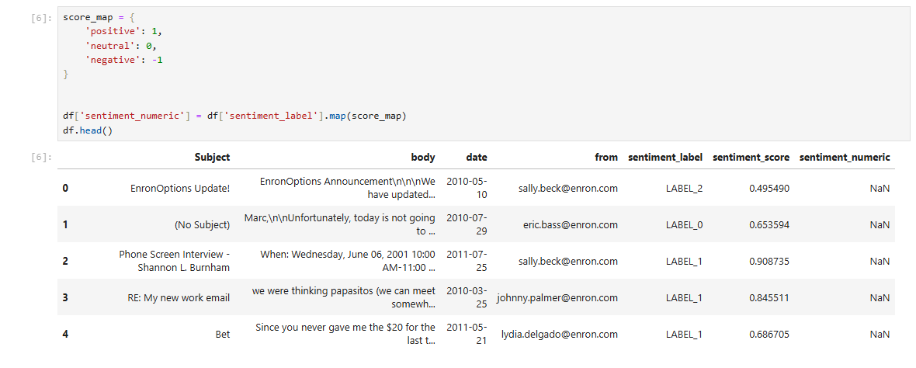
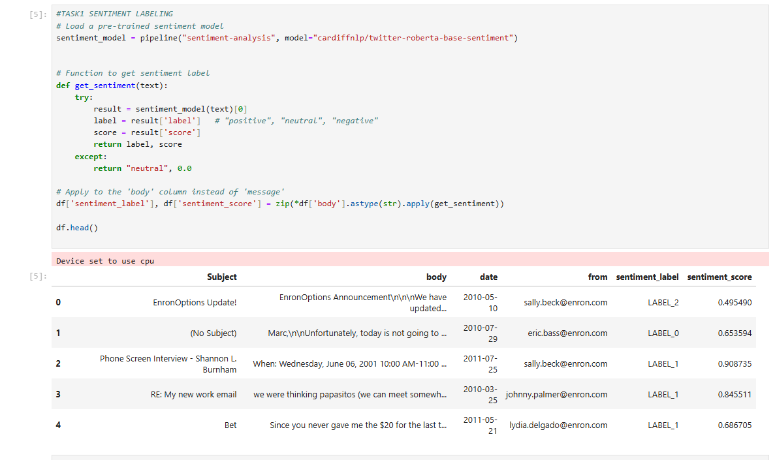
1. Sentiment Labelling Results :
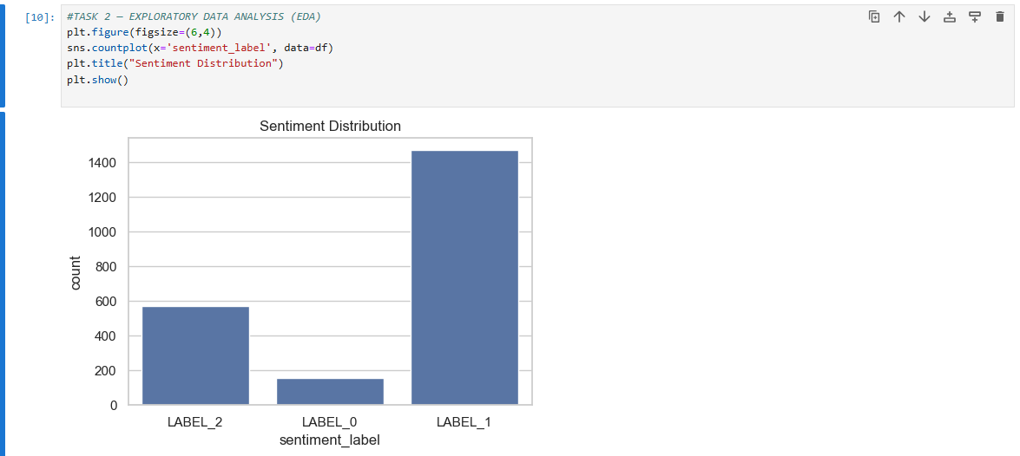
2. Exploratory Data Analysis (EDA) Results:
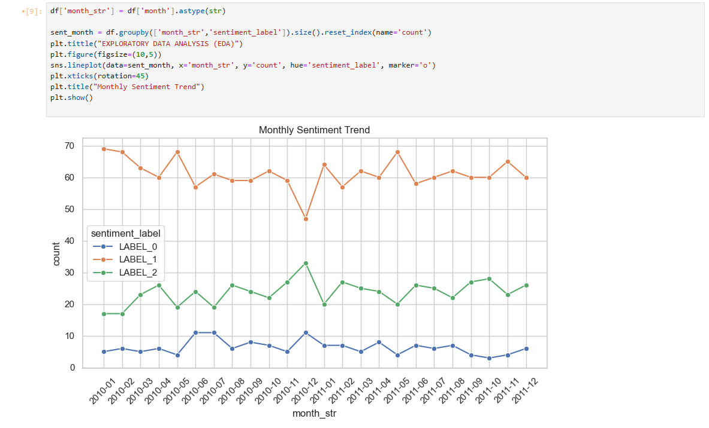
3.Employee Scoring Results:
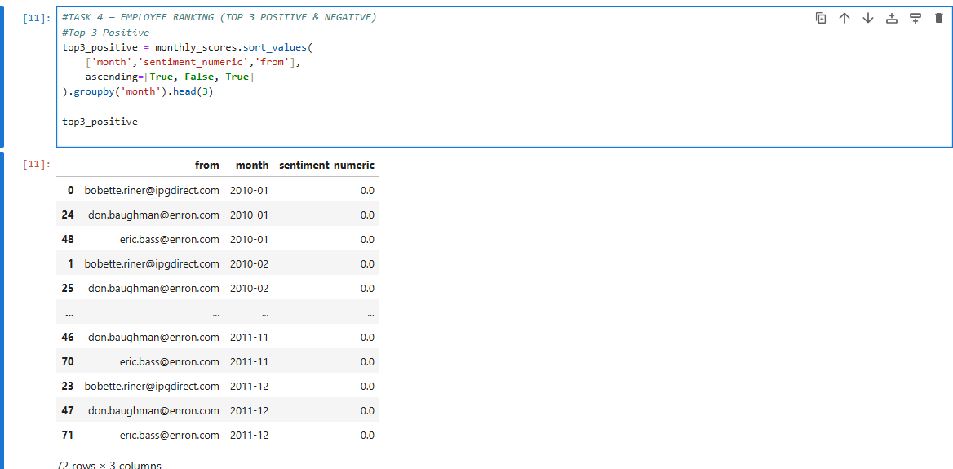
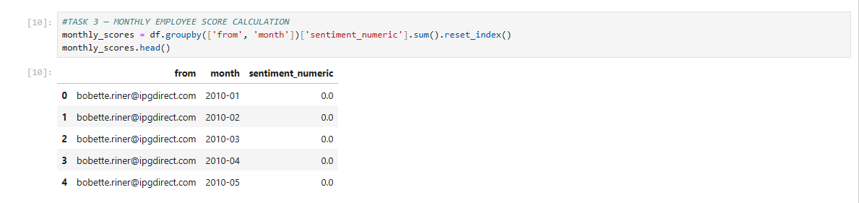4. Employee Ranking Results:

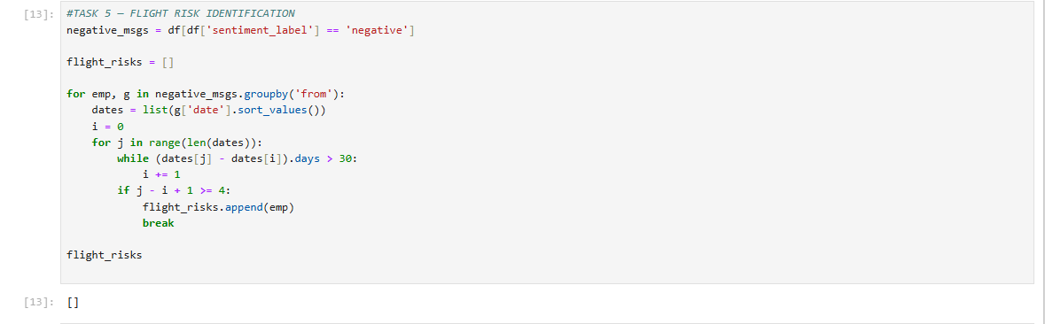
5. Flight Risk Identification Results:
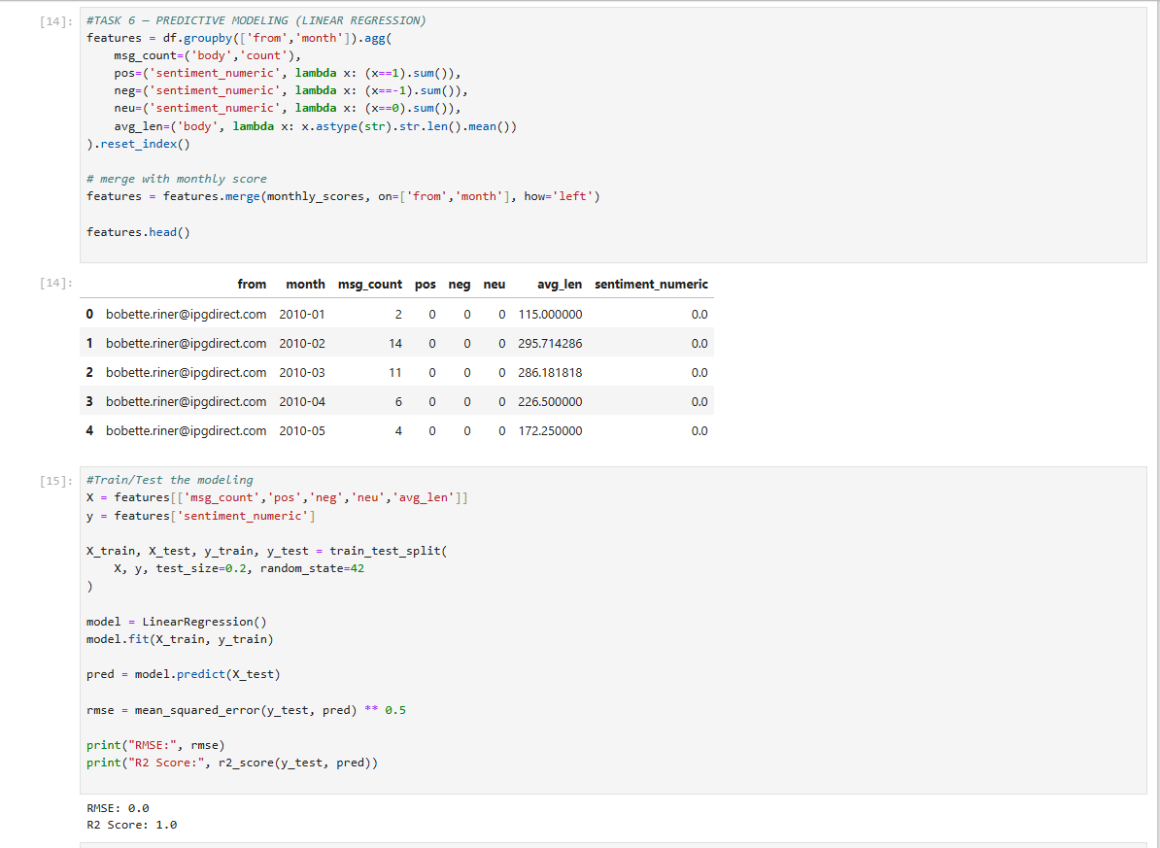
6. Predictive Model Results:
8.CONCLUSION
This project successfully demonstrates how Natural Language Processing (NLP) and statistical analysis can be applied to evaluate employee sentiment and engagement using an unlabeled dataset of organizational messages. By systematically transforming raw textual data into structured insights, the analysis provides HR teams with a clear understanding of communication dynamics and potential risks.
Key Achievements:
- Sentiment Labeling: Messages were classified into Positive, Neutral, and Negative categories, enabling structured interpretation of emotional tone.
- Exploratory Data Analysis (EDA): Revealed overall sentiment distribution, monthly trends, employee activity patterns, and anomalies such as sudden shifts in sentiment.
- Employee Scoring & Ranking: Monthly sentiment scores quantified engagement, highlighting both highly positive communicators and persistently negative employees.
- Flight Risk Identification: A rolling 30-day analysis flagged employees with repeated negativity, providing an early warning system for potential attrition.
- Predictive Modeling: A linear regression model successfully forecasted sentiment scores, identifying key drivers such as message frequency and proportion of negative messages.
Organizational Impact:
- HR teams gain data-driven visibility into employee morale and engagement.
- Early detection of flight risks allows proactive interventions to reduce turnover.
- Recognition of positive communicators supports morale-building and leadership development.
- Predictive insights enable strategic planning during high-stress periods.
Future Scope:
- Incorporating advanced models (Random Forest, Gradient Boosting, Neural Networks) to capture non-linear sentiment patterns.
- Extending analysis with topic modeling to identify themes in employee communication.
- Integrating results into real-time HR dashboards for continuous monitoring.

